Allington Millennium Green Management Plan

Updated January 2020, and subject to regular reviews

Brian White

(With acknowledgement to Mark Pritchard of the Medway Valley Countryside Partnership, who wrote the original management plan in February 2008, and to Emma Ventham of Kent Wildlife Trust Consultancy, who carried out a wildlife survey in 2016.)

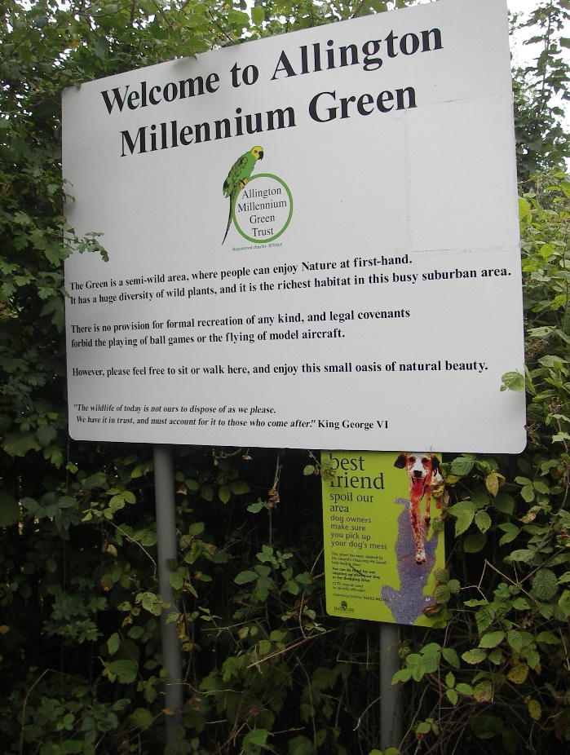

Table of contents

- Executive summary

- Site habitat compartments description

- Key objectives and management proposals

- Constraints

- Health and safety

- Executive summary
Allington Millennium Green (AMG) is one of many such schemes throughout the country. They were funded originally by the Millennium Commission, through the Countryside Commission (now Natural England), and they are permanent areas of outside space to be enjoyed by their local communities. They are in, or close to, cities, towns or villages, are within walking distance of homes and are designed and maintained by local people.

Allington Millennium Green Trust (AMGT) is a registered charity, no 1075165, and it owns and manages the Millennium Green. The Trust has a Sole Corporate Trustee, Allington Millennium Green Limited (AMGL). The directors of the limited company are local residents. Since 1999, the directors and other volunteers have managed the site.

This management plan aims to advise the Trust, volunteers and residents about future short- and long-term management of the site, so that it can achieve its full potential. The plan will also be useful when making bids for funding.

The 0.85 ha site is located at Cloudberry Close, Allington, Maidstone, Kent,
ME16 0LY. The OS grid reference to the centre of the survey area is TQ748565. It is bounded to the north-west by Buckland Lane, to the south-west by the main A20 London Road, and to the north-east by Cloudberry Close. The south-eastern boundary abuts residential properties.

The Green is in an urban area, so it is an important communal open space. Currently, it is not covered by any nature conservation designations and there are no designated nature conservation areas occurring within a one-kilometre radius of the site. It is popular with dog walkers throughout the year and, with families during the summer; thus it contributes to the physical and psychological well-being of the local community. The Green is open to the public at all times and it has three kissing gate entrances: one from Cloudberry Crescent, one from Buckland Lane and the other off the A20.

The land was originally the sports ground for the Sharp’s toffee company, and it was passed to AMGT by Antler Homes, following the building of homes on neighbouring land. The remit was to provide a quiet area for relaxation and for the benefit of wildlife. With the help of the Medway River Project (now Medway Valley Countryside Partnership), the site was developed to reflect the agricultural history of the local area. This included planting cobnut plats, woodland areas and hedges with native species, an orchard and meadows.

In 1801, the main crop grown in Allington was wheat, followed by peas, beans, barley and oats. Tithe records from 1883 show the Millennium Green site as a fruit plantation with a Roman villa nearby. The six-acre site was split into three plots. The first, a house and garden, was owned and occupied by a William Horatio Bensted. Two further plots, each comprising a house, garden buildings and fruit plantation, were each owned and occupies by a Frederick John Crisp and a Frederick William Ruck.

The site has matured to provide a mosaic of habitats which support a diversity of plant life, with plenty of foraging, sheltering and nesting and commuting opportunities for a range of animals and insects. In 2016, the professional wildlife survey identified the presence of a wide range of plants and the potential for many animals to occur on the site, including invertebrates such as bees, butterflies, moths, flies and beetles, amphibians and reptiles, birds, bats and other small mammal species.

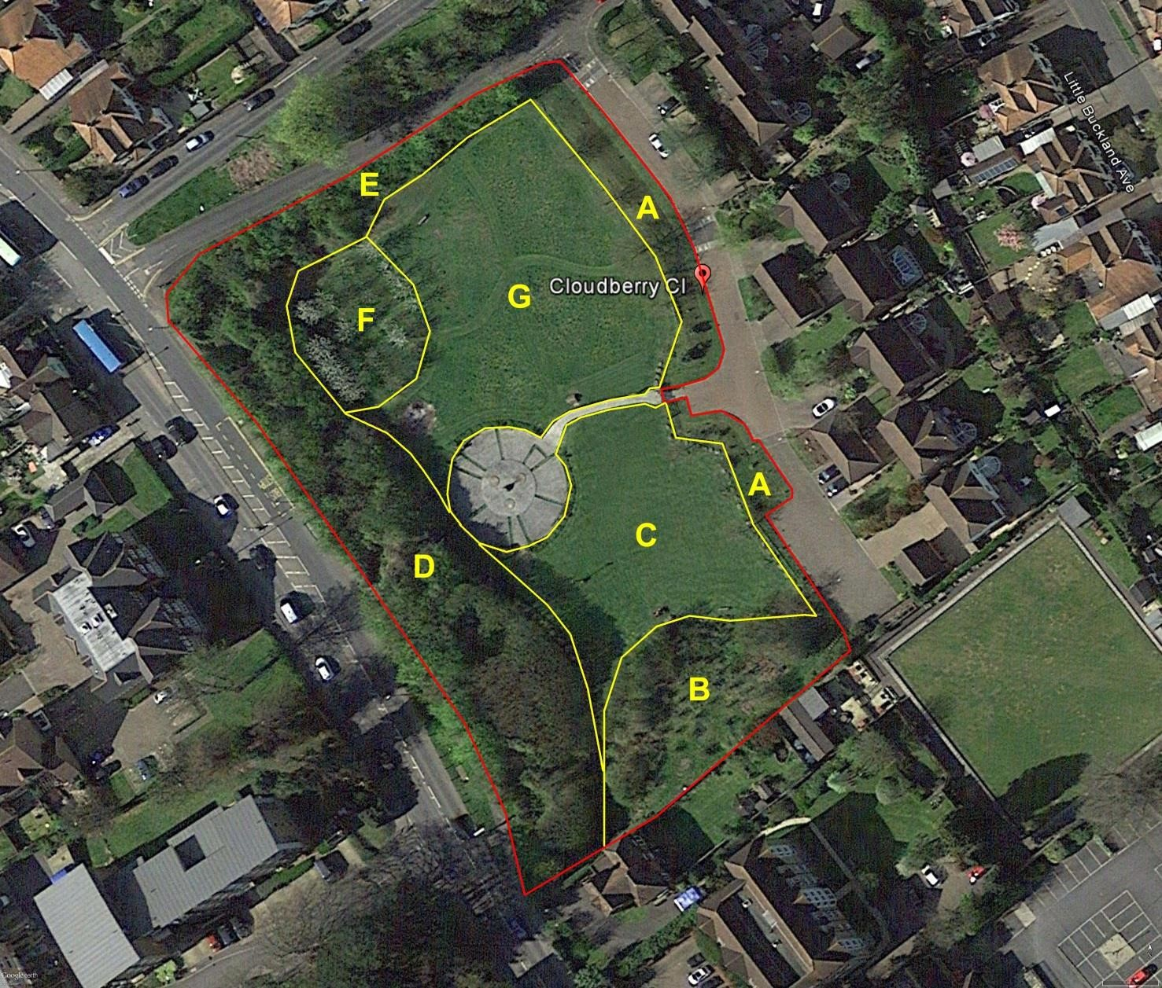
- Site habitat compartments description

This aerial photograph shows compartments outlined in yellow, which were identified as part of the wildlife survey. The yellow letters are used for identification of compartments within the text.

Compartment A: Amenity grassland with non-native planting
This compartment is bisected by the main access to the Millennium Green. It comprises an area of amenity grassland with a slight, east-facing slope leading down to Cloudberry Close. It is bounded by a chestnut knee-rail. There are some non-native shrubs, and the grass is mowed regularly.

Compartment B: South-eastern bank, including glade area and cobnut plat
A bank leads up to an open glade area situated behind a cobnut plat.

Piles of dead wood are created in order to encourage small animals and fungi.

Compartment C: Amenity grass recreational area and sunken central area
The grass is mown to provide an area where people can stroll and children can play. Benches and three picnic benches are provided. The north-eastern boundary has some standard oak trees, and there are unmown areas of plants adjacent to them.

Boulders have been placed along the boundary of this area for both interest value and to provide a barrier against unwanted vehicles; they provide a habitat for lower plants such as mosses and lichens.
The sunken central area was required by the Countryside Commission, and its design helps to link the Green with the Roman heritage of the immediate area. There is a ‘Roman style’ sundial, and digitised images of mosaic designs which were produced to celebrate the Millennium by children at three local primary schools: Allington, Brunswick House and Palace Wood. Benches are provided, and some large Ragstone blocks have been installed in order to give added interest. The sunken central area is surrounded by a chestnut knee-rail.

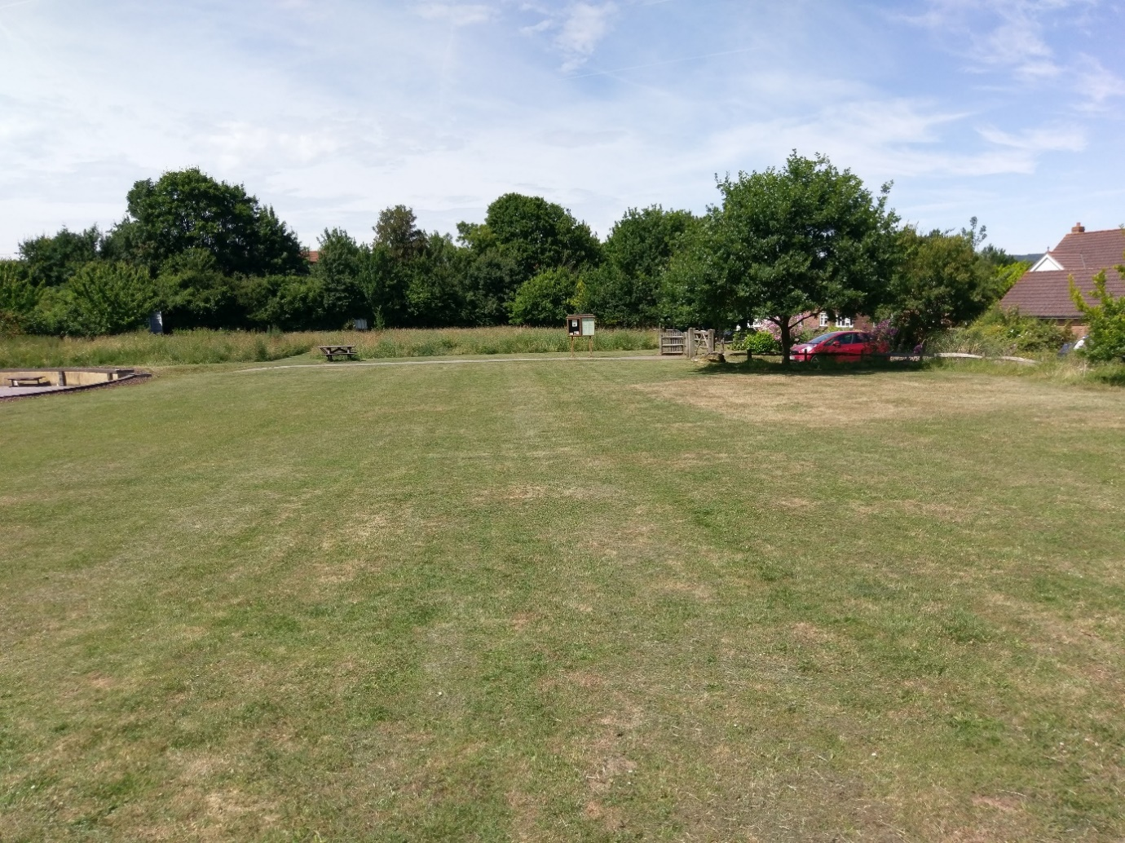
This photograph across the amenity grass recreational area, taken in June, shows the wildflower meadow in the background.

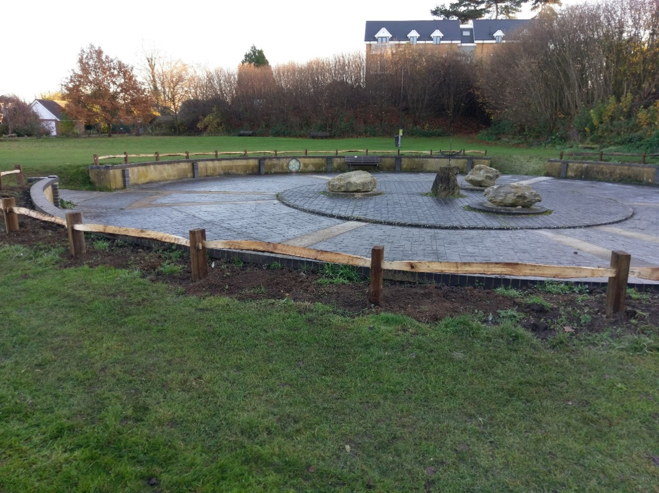
The sunken central area

Compartment D: South-western bank, including cobnut plat and woodland trees
This north-eastern facing sloping bank forms the boundary between the Millennium Green and the A20 London Road. It has been planted with cobnuts, and native tree and shrub species.

A hedge borders the fence beside the highway, and this is being laid, in order to improve its appearance, structure and maintenance. The hedge is comprised of a variety of native shrub and tree species.

The cobnuts are coppiced on a rotational basis.

Piles of dead wood are created in order to encourage small animals and fungi.

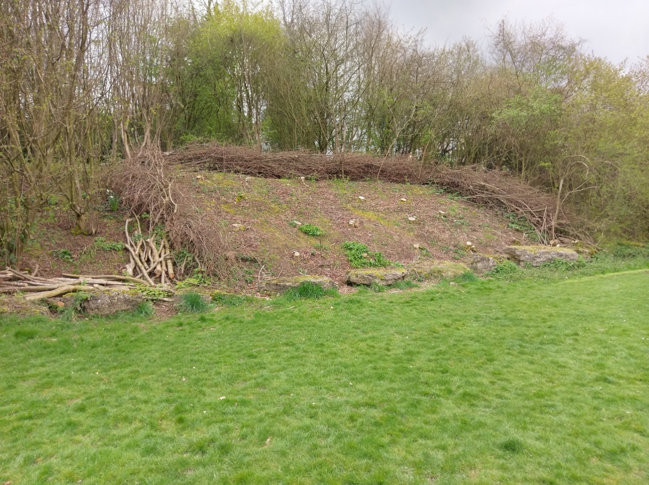
Coppicing of the cobnuts in 2019

Compartment E: North-western boundary hedge
This hedge forms the boundary between the Millennium Green and Buckland Lane. As it comprises more than 80% native species, it qualifies as a S41 Habitat of Principal Importance in England (formerly UK BAP priority habitat). At least part of the hedge will be laid, in order to improve its appearance, structure and maintenance.

Adjacent to the hedge is a storage container, which is used to house the Trust’s tools and equipment.

Compartment F: Orchard with apple and cherry trees
The ground beneath the trees supports a closed, tall grass sward with a mix of herbaceous plants. Pathways are mown through the area.

The following plan shows the locations of the trees.

Apples Cherries
A = Allington Pippin (spur bearer) M = Morello
B = Bramley (partial tip bearer) S = Stella
G = Grenadier (spur bearer)
L = Laxton Superb (tip bearer)
H = Howgate Wonder (spur bearer)
W = Worcester Pearmain (partial tip bearer)

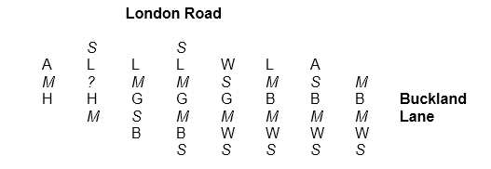
The Allington Pippin and Grenadier are both varieties with a local provenance.

Compost bins are located to the south-west of the orchard area. These were installed so that local residents could make use of the compost, but supply has exceeded the demand.

Next to the compost bins, a refuge has been constructed for small organisms

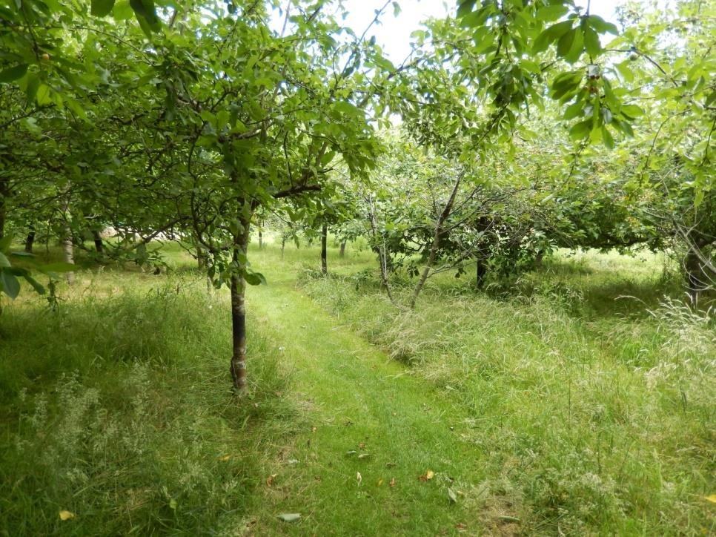

Some of the orchard trees

Compartment G: Wildflower meadow
The meadow is allowed to grow during the spring and summer in order to encourage a range of flowering plants which are native to the area. Footpaths are mown through the meadow: these divide it into four main sections which may be managed in different ways.

- Key objectives and management proposals
- Provide a semi-natural open space for informal recreation.
- Manage the site for biodiversity and as a haven for wildlife.
- Maintain the cobnut plat and wooded banks to screen the road and adjacent apartment buildings.
- Maintain the cobnut plat and orchard to reflect previous agricultural practices.
- Manage the hedges for easy maintenance and biodiversity.
- Adopt a mowing regime in the meadow which will encourage the growth of flowering plants which are native to the area.
- Remove non-native species such as buddleia and sycamore.
- Encourage small animals and fungi by creating piles of dead wood.
- Carry out regular monitoring of flora and fauna.
- Keep maintenance and management as low-level as possible, because labour resources are limited.
- Try to keep the threat of vandalism to a minimum.

- Constraints
- Weather conditions
- Time to compete tasks
- Funding
- Availability of suitable equipment
- Availability of skilled personnel to carry out tasks. (Volunteers, or contractors, if funding allows.)
- Skills in carrying out surveys of flora and fauna. (Some volunteers have received such training.)

- Health and safety and insurance
Public Liability insurance is provided by Zurich.

Risk assessments have been written or modified for all of the common tasks which are might be carried out on the Green. They are as follows:

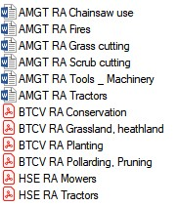

One major health and safety issue, is the fact that there is no waste collection from the Green by Maidstone Borough Council, and the bins contain a lot of dog waste. At present, the waste sacks have to be put into domestic bins at local properties, and this is an unsatisfactory situation.

